

**CAPSTONE PROJECT NORTH WIND TRADERS**

* Aanchal Jain

#### Abstract

The "Capstone Project for Northwind Traders" presents an in-depth analysis of the sales data for the fictitious company "Northwind Traders." This project aims to deliver insights into customer behavior, product performance, sales trends, supplier metrics, and employee performance to support data-driven decision-making. The documentation encompasses various critical aspects, including a project overview, data acquisition, dataset table information, data cleaning processes, MECE (Mutually Exclusive, Collectively Exhaustive) breakdown, Power BI, EDA (Exploratory Data Analysis) questions, and dashboard analysis.

Utilizing interactive visualizations and dynamic filters, the project explores key areas such as customer distribution, acquisition trends, demographics, order volume, order values, employee productivity, tenure, product performance, supplier metrics, and geographical distribution of suppliers. These visualizations and analyses provide significant insights into customer preferences, market segments, product success, and supplier relationships, empowering stakeholders to make informed decisions and identify areas for improvement.

The abstract offers a preview of the detailed analysis and insights derived from the project, highlighting the use of Power BI and EDA to extract valuable information from the dataset. The primary objective of the project is to empower stakeholders with actionable insights and facilitate comprehensive data exploration through interactive visualizations and dynamic filters, ultimately aiding in informed decision-making and driving operational enhancements.

# CONTENTS

#### Introduction

#### Data Acquisition

* Data cleaning

#### MECE-Breakdown

* Understanding & solving Power BI Questions

#### Dashboard

* Understanding & solving EDA Questions

# INTRODUCTION

### Project Overview:

The North Wind Traders Capstone Project is a comprehensive analysis of the sales data for a fictitious company called "North Wind Traders," which imports and exports specialty foods from around the world. The project aims to generate insights into customer behaviour, sales patterns, and employee performance to aid decision-making processes. It covers sales analysis, customer segmentation, inventory trends, and employee performance, consolidating data from multiple tables for a comprehensive view of the company's operations. The objective of the project is to empower stakeholders to make data- driven decisions by offering valuable insights and facilitating data exploration through interactive visualizations and dynamic filters. The project utilizes MySQL for database management, Excel, and Power BI for data visualization to extract meaningful information from the dataset and offers sample visualizations and analyses to showcase the use of interactive visualizations and dynamic filters. The project's key functionality includes sales analysis, customer segmentation, inventory trends, employee performance analysis, product performance evaluation, supplier metrics visualization, and interactive visualizations and dynamic filters. The project's documentation includes a project overview, data acquisition, information about dataset tables, data cleaning and MECE- breakdown, Power BI and EDA questions, dashboard analysis, and conclusion.

##### Introduction of data set Table:

The North Wind Traders Capstone Project includes several tables that store information about the company's operations.

Data dictionary for the Northwind database based on the provided tables:

##### Customers Table

This table stores information about the company's customers.

* CustomerID: Unique identifier for each customer.
* CompanyName: Name of the customer's company.
* ContactName: Name of the contact person at the company.
* ContactTitle: Title of the contact person.
* Country: Country where the customer is located.
* City: City where the customer is located.

##### Employees Table

This table stores information about the company's employees.

* EmployeeID: Unique identifier for each employee.
* LastName: Last name of the employee.
* FirstName: First name of the employee.
* Title: Job title of the employee.
* TitleOfCourtesy: Title of courtesy (Mr., Mrs., etc.) for the employee.
* BirthDate: Date of birth of the employee.
* HireDate: Date when the employee was hired.
* Address: Street address of the employee.
* City: City where the employee is located.
* Region: Region or state where the employee is located.
* PostalCode: Postal code or ZIP code of the employee's location.
* Country: Country where the employee is located.
* HomePhone: Home phone number of the employee.
* Extension: Extension number for contacting the employee.
* Photo: Binary data of the employee's photograph.
* Notes: Additional notes about the employee.
* ReportsTo: ID of the employee's manager (links to another EmployeeID).
* PhotoPath: File path to the employee's photograph.

##### Orders Table

This table stores information about the company's orders.

* OrderID: Unique identifier for each order.
* CustomerID: ID of the customer who placed the order (links to CustomerID in Customers table).
* EmployeeID: ID of the employee who processed the order (links to EmployeeID in Employees table).
* OrderDate: Date when the order was placed.
* RequiredDate: Date when the order is required by.
* ShippedDate: Date when the order was shipped.
* ShipVia: ID of the shipping company used for the order (links to ShipperID in Shippers table).
* Freight : Cost of shipping.
* ShipName: Name of the person or company receiving the shipment.
* ShipAddress: Street address of the shipment destination.
* ShipCity: City of the shipment destination.
* ShipRegion: Region or state of the shipment destination.
* ShipPostalCode: Postal code of the shipment destination.
* ShipCountry: Country of the shipment destination.

##### Order Details Table

This table stores detailed information about the items within each order.

* OrderID: ID of the order (links to OrderID in Orders table).
* ProductID: ID of the product ordered (links to ProductID in Products table).
* UnitPrice: Price per unit of the product at the time of the order.
* Quantity: Number of units ordered.
* Discount: Discount applied to the product in the order.

##### Products Table

This table stores information about the company's products.

* ProductID: Unique identifier for each product.
* ProductName: Name of the product.
* SupplierID: ID of the supplier for the product (links to SupplierID in Suppliers table).
* CategoryID: ID of the category to which the product belongs (links to CategoryID in Categories table).
* QuantityPerUnit: Description of the quantity of product per unit.
* UnitPrice: Price per unit of the product.
* UnitsInStock: Number of units currently in stock.
* UnitsOnOrder: Number of units currently on order with suppliers.
* ReorderLevel: Inventory level that triggers a reorder of the product.
* Discontinued: Indicates if the product has been discontinued.

##### Suppliers Table

##### This table stores information about the company's suppliers.

* SupplierID: Unique identifier for each supplier.
* CompanyName: Name of the supplier's company.
* ContactName: Name of the contact person at the supplier's company.
* ContactTitle: Title of the contact person.
* Address: Street address of the supplier.
* City: City where the supplier is located.
* Region: Region or state where the supplier is located.
* PostalCode: Postal code or ZIP code of the supplier's location.
* Country: Country where the supplier is located.
* Phone: Contact phone number of the supplier.
* Fax: Fax number of the supplier.
* HomePage: URL for the supplier's website.

##### Shippers Table

This table stores information about the company's shipping companies.

* ShipperID: Unique identifier for each shipper.
* CompanyName: Name of the shipping company.
* Phone: Contact phone number of the shipping company.

##### Categories Table

This table stores information about the product categories.

* CategoryID: Unique identifier for each category.
* CategoryName: Name of the category.
* Description: Description of the category.

##### Reason For the Project:

The North Wind Traders Capstone Project aims to create a visually appealing and user-friendly dashboard that communicates key performance metrics effectively. The project's objective is to generate

insights into customer behavior, sales patterns, and employee performance to aid decision-making processes. It covers sales analysis, customer segmentation, inventory trends, and employee performance, consolidating data from multiple tables for a comprehensive view of the company's operations. The report is designed to empower stakeholders to make data-driven decisions by offering valuable insights and facilitating data exploration through interactive visualizations and dynamic filters. The expected impact of the project is to revolutionize how North Wind Traders interacts with its data, enabling the company to remain competitive and drive its business forward in the wholesale market landscape. The dataset includes tables for customers, employees, orders, order details, products, suppliers, shippers, and categories, providing a rich source of information for the analysis. The project involves data cleaning and MECE-breakdown to ensure the quality and structure of the data. Additionally, it includes a set of Power BI and EDA (Exploratory Data Analysis) questions to guide the analysis and visualization process, covering various aspects such as customer distribution, order volume, employee productivity, product performance, supplier metrics, and customer retention. The project's comprehensive approach and the use of interactive visualizations and dynamic filters are aimed at providing a deep understanding of the company's operations and facilitating informed decision-making.

### Key Functionality of the Project:

The key functionalities of this Power BI project for Northwind Traders include:

###### Data Integration and Transformation:

Importing and integrating data from multiple tables (Customers, Employees, Orders, etc.) into Power BI.

Performing data transformations such as cleaning, shaping, and merging to prepare the data for analysis.

###### Visual Data Exploration:

Creating interactive visualizations to explore key performance metrics such as sales trends, customer segmentation, inventory levels, and employee performance.

Utilizing various chart types (line charts, bar charts, pie charts, etc.) to present data in a meaningful and visually appealing manner.

Implementing slicers, filters, and drill-down capabilities to allow users to dynamically interact with the data and gain deeper insights.

###### Sales Analysis:

Analyzing sales data to identify trends, patterns, and opportunities for growth. Calculating key sales metrics such as total revenue, average order value, and sales by product category or region.

Visualizing sales performance over time and comparing it with historical data to track progress.

###### Customer Segmentation:

Segmenting customers based on demographic data (location, industry, etc.) to better understand their behavior and preferences.

Creating visualizations to show the distribution of customers across segments and analyze their purchasing patterns.

Identifying high-value customers and developing targeted marketing

strategies to enhance customer engagement and retention.

###### Inventory Management:

Monitoring inventory levels and trends to optimize stock levels and minimize stockouts.

Calculating inventory metrics such as turnover rate, stock levels, and reorder frequency.

Visualizing inventory data to identify slow-moving items, excess stock, and potential supply chain issues.

###### Employee Performance Analysis:

Evaluating employee sales performance based on metrics such as total sales, number of orders processed, and average order value.

Ranking employees by performance and identifying top performers for recognition and reward.

Providing insights into employee productivity and effectiveness to inform decision-making and performance management.

**Interactive Dashboards and Reports:** Designing interactive dashboards with a user-friendly layout and intuitive navigation. Incorporating storytelling elements to guide users through the data and highlight key insights.

Enabling users to customize views, apply filters, and drill down into specific data points for deeper analysis.

###### Report Sharing and Collaboration:

Publishing the Power BI report to the Power BI Service for online access. Sharing the report with relevant stakeholders and teams within the organization. Collaborating on data analysis and decision-making by providing access to the report and facilitating discussions around the insights generate

### Aim and Objective:

**Consolidate Data:** Integrate and consolidate data from multiple tables within the Northwind database to provide a comprehensive view of the company's operations.

**Analyze Sales Patterns:** Analyze sales data to identify trends, patterns, and fluctuations in sales performance over time, by product, region, and customer segment.

**Understand Customer Behavior:** Analyze customer data to understand buying behavior, preferences, and demographics, enabling targeted marketing strategies and improved customer engagement.

**Optimize Inventory Management:** Monitor inventory levels, analyze stock movement, and identify inventory trends to optimize inventory management processes and reduce carrying costs.

**Evaluate Employee Performance:** Assess employee sales performance, productivity, and effectiveness to identify top performers, training needs, and opportunities for improvement.

**Provide Actionable Insights:** Present insights derived from data analysis in a visually appealing and intuitive dashboard format, enabling stakeholders to make informed decisions and take proactive actions.

**Foster Data-Driven Culture:** Promote a culture of data-driven decision-making within the organization by providing access to timely and relevant data, empowering stakeholders at all levels to leverage data for strategic planning and operational improvements.

**Enhance Business Competitiveness:** Use data insights to identify competitive advantages, market opportunities, and areas for innovation, enabling Northwind Traders to stay ahead in the wholesale market landscape**.**

**Facilitate Continuous Improvement:** Continuously monitor and analyze key performance metrics, gather feedback from stakeholders, and iterate on the Power BI dashboard to ensure it remains relevant, insightful, and aligned with business objectives.

By achieving these objectives, the Power BI project aims to empower Northwind Traders with actionable insights, enabling them to make informed decisions, drive business growth, and maintain a competitive edge in the marketplace.

DATA CLEANING

###### Data cleaning is the process of identifying and correcting or removing errors, inconsistencies, and inaccuracies in data. It is an important step in data analysis as it ensures that the data is accurate, complete, and consistent. Data cleaning is used to improve the quality of data and to make it suitable for analysis. It involves identifying missing values, removing duplicates, correcting spelling errors, and standardizing data formats. Data cleaning is essential because it helps to ensure that the insights generated from the data are reliable and accurate.

**Some common challenges faced during data cleaning include: Missing Data:** Dealing with missing values in the dataset, which may require imputation or removal of incomplete records.

Inconsistent

**Data:** Addressing inconsistencies in data formats, such as date formats, currency symbols, or units of measurement.

**Duplicate Records:** Identifying and removing duplicate entries, which can skew analysis and lead to inaccurate results.

**Outliers:** Handling outliers that can significantly impact statistical analysis and visualization.

**Data Standardization:** Ensuring that data is consistent and standardized across different sources or systems.

**Data Validation:** Verifying the accuracy and integrity of the data, which may involve cross-referencing with external sources or known benchmarks.

**Data Transformation:** Converting data into a suitable format for analysis, such as aggregating, pivoting, or normalizing data.

**Data Quality:** Ensuring the overall quality of the data, including accuracy, completeness, and reliability.

These challenges are common in the data cleaning process and require careful attention to detail to ensure the accuracy and integrity of the data for analysis.

**Process of Cleaning in North Wind dataset tables:**

* **Customers table:**

#### In Customer table region column contain many null values that are replaced with N/A.

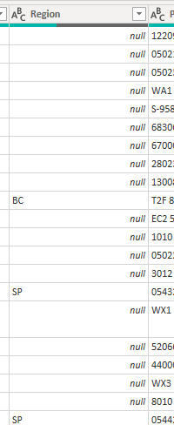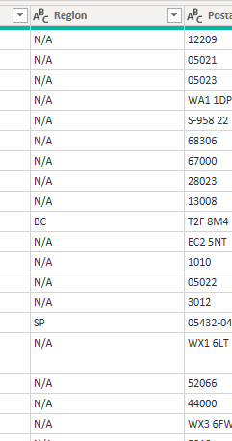

* After this removed these columns that are not necessary for the visualization. These columns are Phone, Fax, Image and Image Thumbnail

### Employee table:

From the employee table these columns are removed that are not providing and information for visualization. These columns are Home Phone, Photo, Report To.

### Supplier table:

Supplier table also contain these columns that are not necessary for visualization. These columns are Phone, Fax, Home Page.

* **Categories table:** categories table contain one column that are not necessary for visualization**.**

##### After cleaning all the table are used for the visualization in power BI and build a relationship between the tables :

* + **Employees table connected to the orders table.**

##### Customer table connected to the orders table.

* + **Supplier table connected to the Product table.**

##### Product table connected to the order details and categories table.

* + **Order details table connected to the orders table.**

##### Shipper table also connected to the orders table.

All the tables are connected with each in a one-to- many relationship.

### Overview of Transformed dataset (North wind

**traders)**

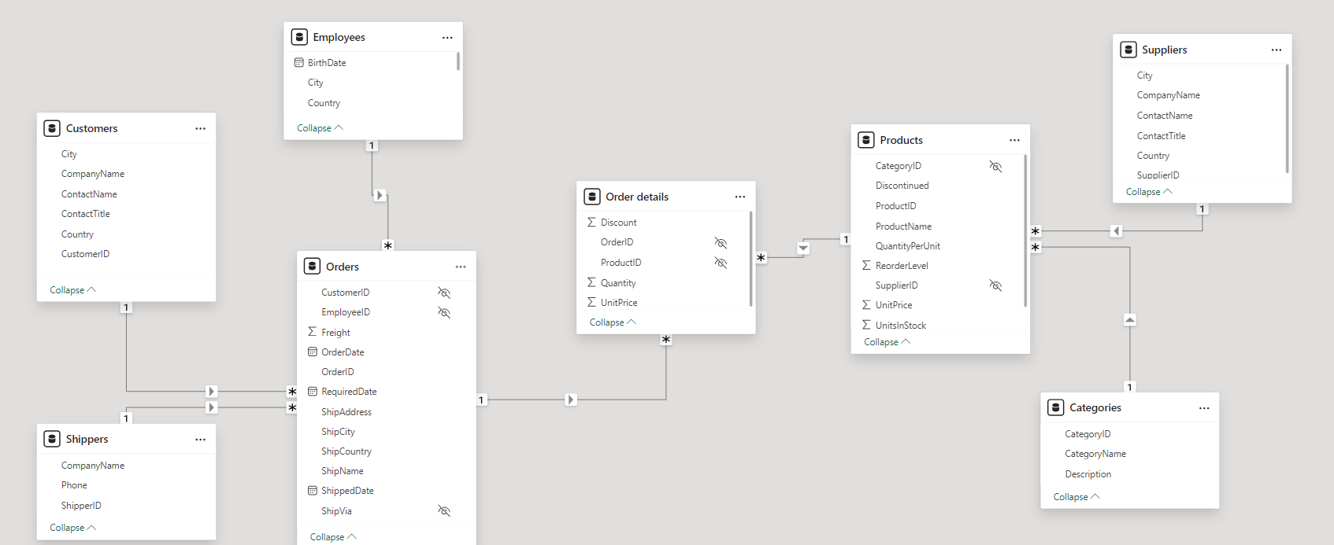

**Entity Relationship Diagram**

### MECE-Breakdown:

MECE stands for "Mutually Exclusive, Collectively Exhaustive." It's a principle often used in problem- solving and structuring information to ensure that all elements being considered are distinct from one another (mutually exclusive) and that together they cover all possible options (collectively exhaustive).

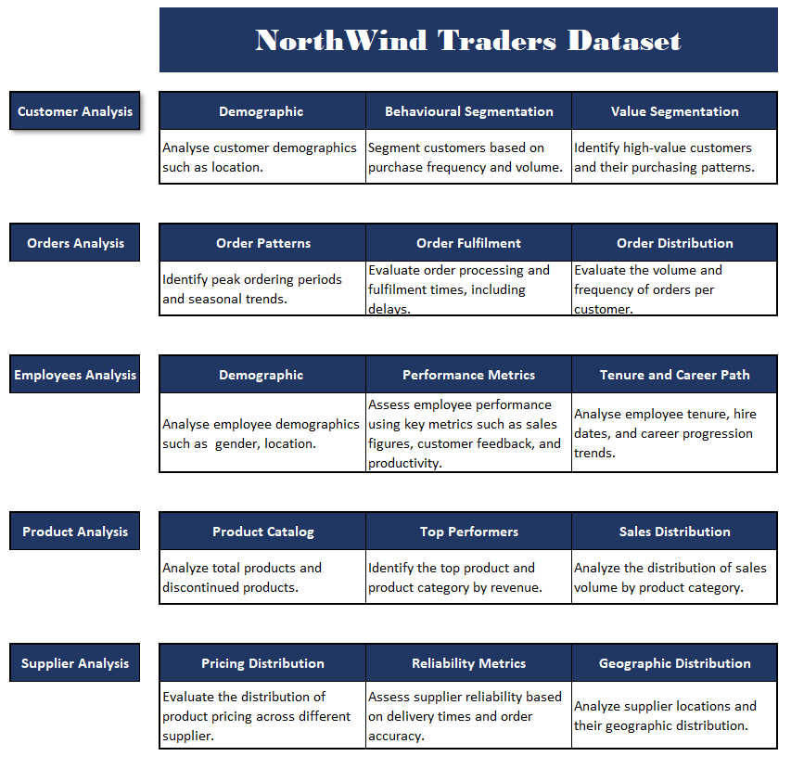

# POWER BI QUESTIONS

1. **How does customer distribution vary across different regions or customer segments? Can we visualize it on a map or bar chart?**
2. **What is the trend in customer acquisition over time? Can we create a line chart or area chart to display it?**
3. **Can we visualize the distribution of customer demographics such as age, gender, or income using histograms or pie charts?**
4. **How does order volume change over time? Can we create a time series chart or stacked bar chart to visualize it?**
5. **What is the distribution of order values? Can we create a histogram or box plot to display it?**
6. **Can we visualize the average order processing time or shipping duration using a bar chart or box plot?**
7. **How does employee productivity vary across different departments or job roles? Can we create a stacked bar chart or grouped column chart to visualize it?**
8. **What is the distribution of employee tenure? Can we create a histogram or box plot to display it?**
9. **Can we visualize employee performance ratings or KPIs using a radar chart or bullet graph?**
10. **What is the distribution of product ratings or reviews? Can we create a histogram or stacked bar chart to visualize it?**
11. **How does the sales volume vary across different product categories? Can we create a bar chart or treemap to display it?**
12. **Can we visualize the pricing distribution of products using a box plot or violin plot?**
13. **What is the distribution of supplier ratings or performance metrics? Can we create a bar chart or radar chart to visualize it?**
14. **How does the cost or pricing structure vary across different suppliers? Can we create a box plot or stacked bar chart to display it?**
15. **Can we visualize the geographical distribution of suppliers using a map or bubble chart?**

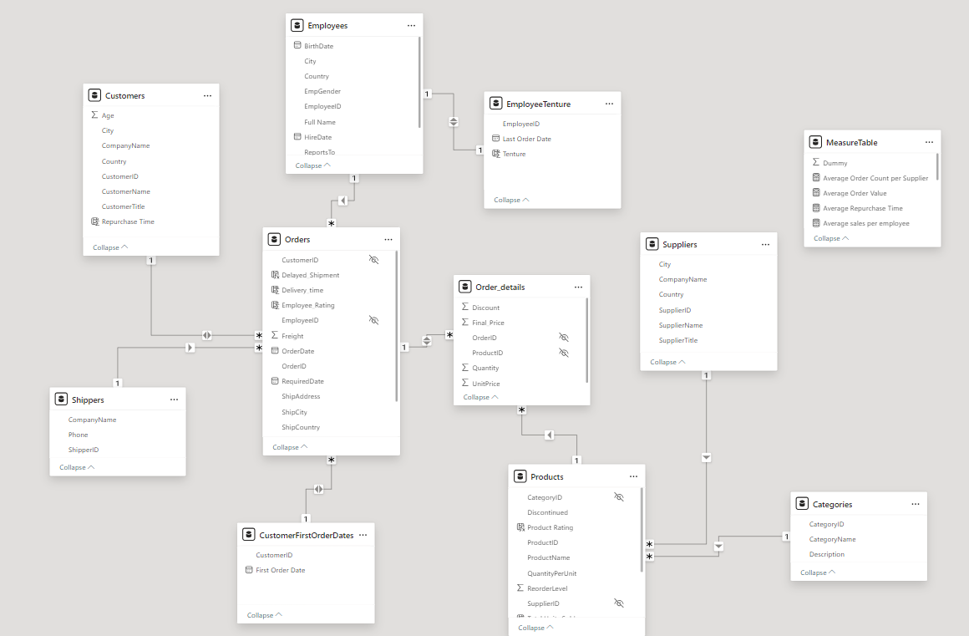

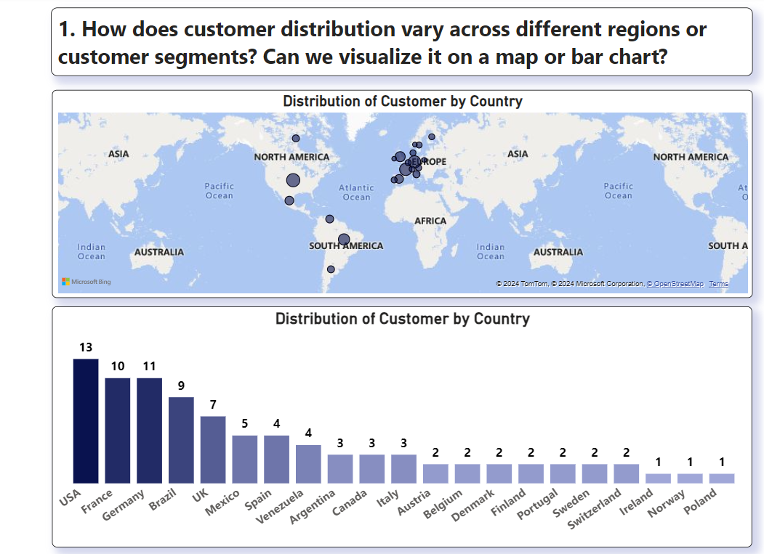

**Conclusions:**

* **USA** has the most customers, followed by **France** and **Germany**.
* **Europe** dominates the customer base.

**Insights:**

* **Expand in Europe:** Strengthen market presence in Europe.
* **Explore Growth:** Investigate opportunities in countries with fewer customers.
* **Targeted Marketing:** Segment customers by location for effective campaigns.

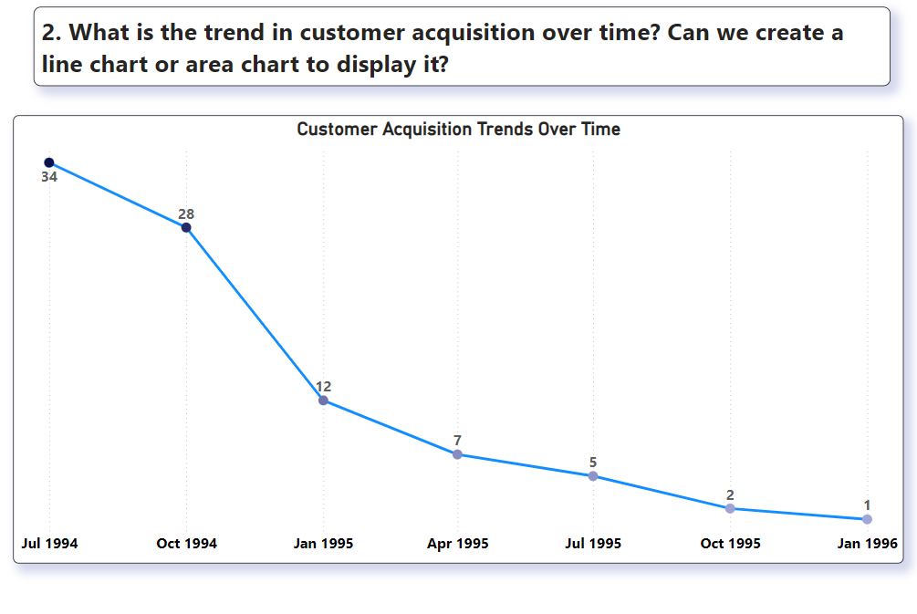

**Conclusions:**

* **Decline** in customer acquisition from July 1994 to January 1996.
* **Peak** in July 1994.

**Insights:**

* **Analyze Decline:** Investigate the reasons for the drop.
* **Improve Retention:** Focus on keeping existing customers.
* **Revise Marketing:** Update strategies to attract new customers.

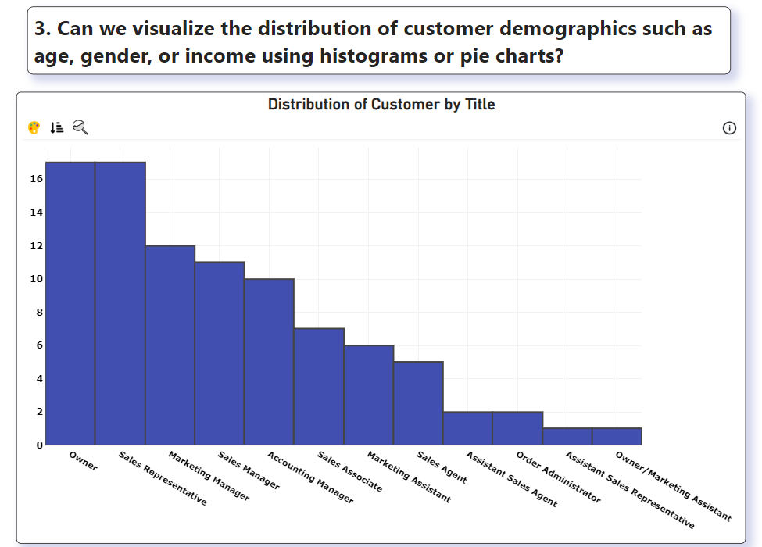

**Conclusions:**

* Most customers are **Owners**, **Sales Representatives**, and **Marketing Managers**.
* Fewer customers have **Assistant** roles.

**Insights:**

* **Target Key Titles:** Focus marketing on Owners, Sales Representatives, and Marketing Managers.
* **Understand Needs:** Offer solutions tailored to these roles.
* **Niche Opportunities:** Create products for roles with fewer customers.

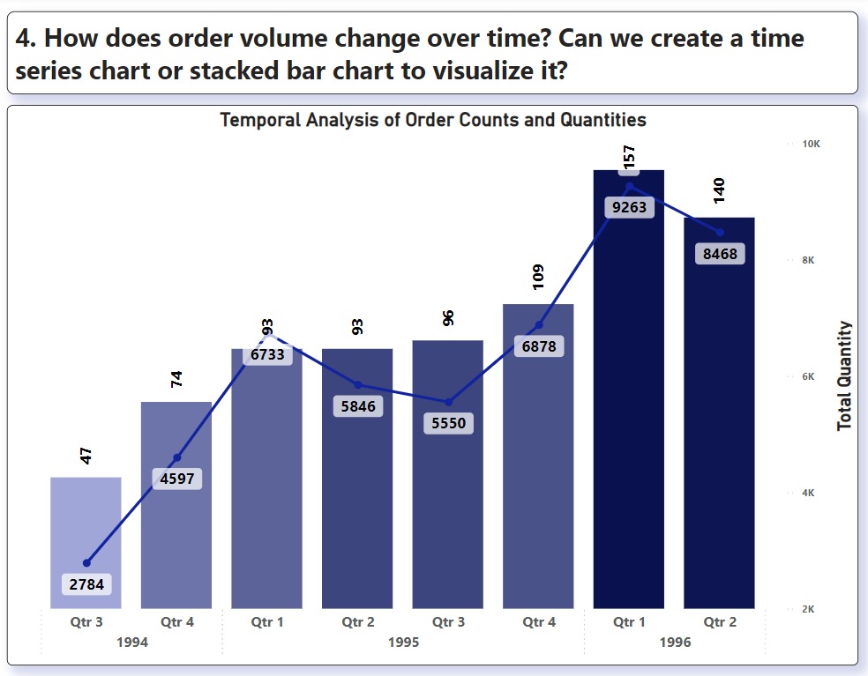

**Conclusions:**

* There is a noticeable increase in order volume from Q3 1994 to Q1 1996.
* The total quantity ordered also shows a general upward trend, with Q1 1996 having the highest quantity.
* There are fluctuations in the number of orders per quarter, but the overall trend is increasing.

**Actionable Insights:**

* **Resource Allocation**: Prepare for higher demand in the first quarters of each year based on historical trends.
* **Marketing Strategies**: Intensify marketing efforts leading up to Q1 to capitalize on the increase in order volume.
* **Inventory Management**: Ensure sufficient stock levels in anticipation of higher order quantities, especially in Q1.

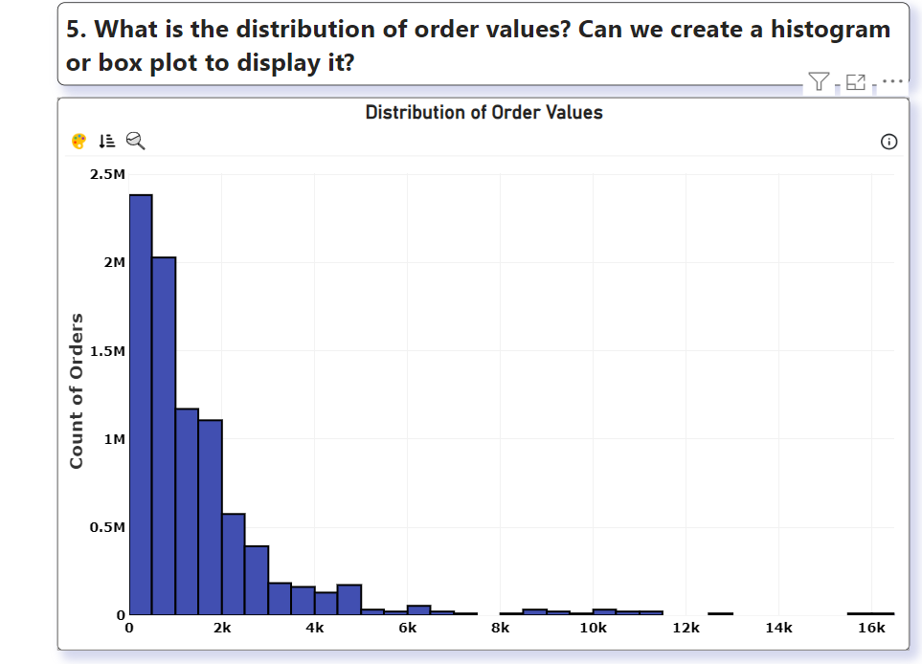

**Conclusions:**

* The majority of orders fall within the lower value ranges (0 to 2,000).
* There is a long tail distribution, with a small number of high-value orders extending up to 16,000.

**Actionable Insights:**

* **Targeted Promotions**: Implement targeted promotions and discounts for higher-value orders to encourage customers to make larger purchases.
* **Customer Segmentation**: Segment customers based on order values to tailor marketing campaigns effectively.
* **Sales Focus**: Train the sales team to upsell and cross-sell to customers with historically lower order values to increase their average order size.

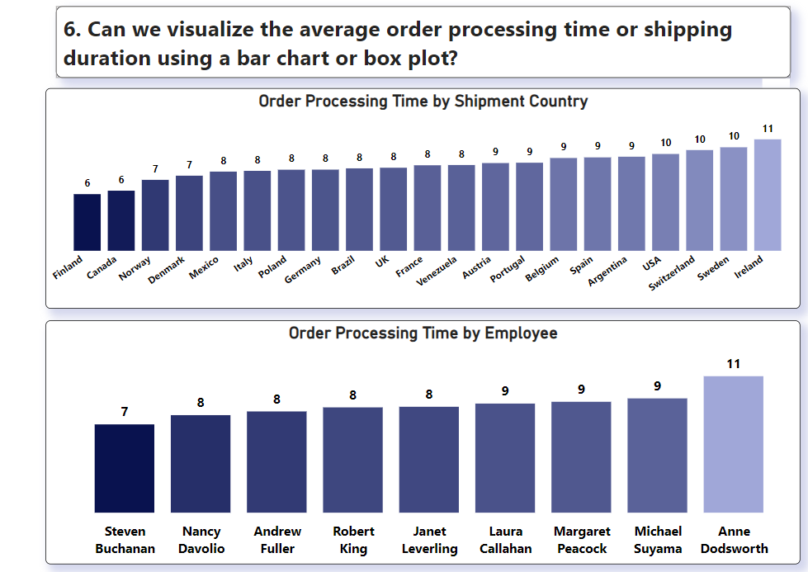

**Conclusions:**

* **By Shipment Country**: Order processing times vary by country, with Finland having the shortest average processing time (6 days) and Ireland the longest (11 days).
* **By Employee**: There are differences in processing times among employees, with Steven Buchanan having the shortest average processing time (7 days) and Anne Dodsworth the longest (11 days).

**Actionable Insights:**

* **Process Improvement**: Investigate reasons for longer processing times in certain countries and streamline processes to reduce delays.
* **Employee Training**: Provide additional training and support to employees with longer processing times to improve their efficiency.
* **Performance Incentives**: Implement performance incentives for employees to encourage faster order processing while maintaining accuracy and quality.

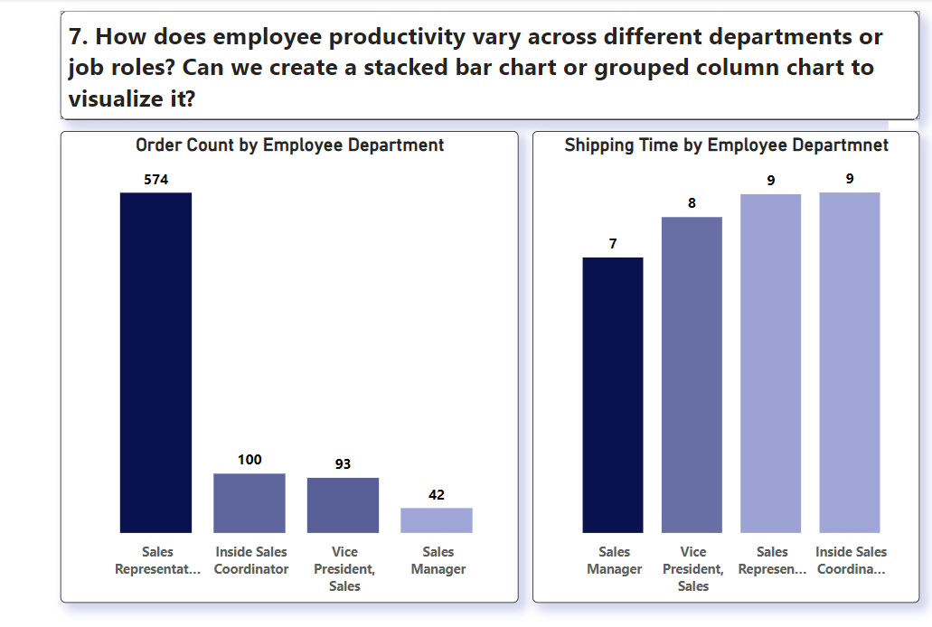

**Conclusions:**

* **Sales Representatives** are handling the **highest order volume**, but have **longer shipping times** compared to other roles.
* The Vice President of Sales processes fewer orders but has the second-fastest shipping time.

**Actionable Insights:**

* Consider redistributing workload or providing additional support to Sales Representatives to improve shipping times while maintaining their high order volume.

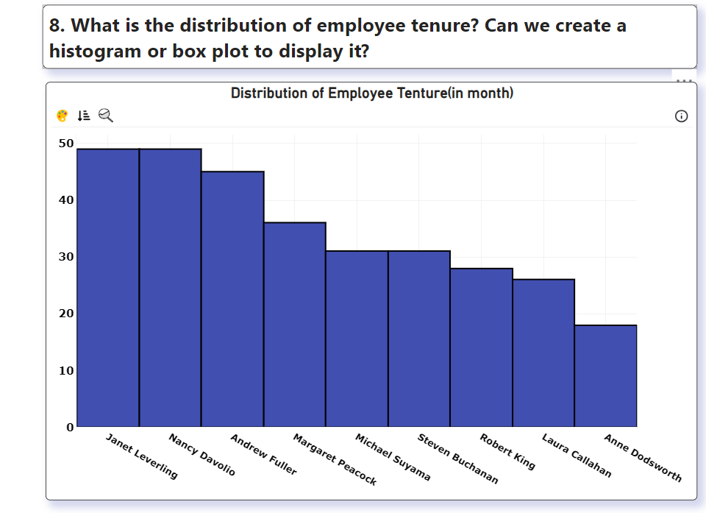

**Conclusions:**

* **Janet and Nancy** are the **longest-serving employees,** while **Anne** has the **shortest tenure.**
* The duration of employee tenure ranges from **18 to 50 months.**

**Actionable Insights:**

* Analyze factors contributing to long-term employee retention and implement strategies to improve retention for newer employees. Consider knowledge transfer programs between long-tenured and newer employees.

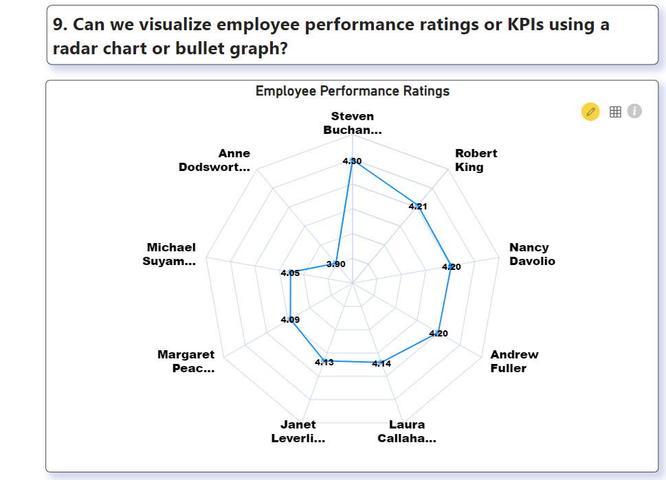

**Conclusions:**

* **Steven Buchanan** has the highest performance rating **(4.80),** while others like **Michael Suyama** have lower ratings **(3.90).**

**Actionable Insights:**

* Identify best practices from top performers like Steven Buchanan and implement training programs to improve overall team performance.
* Provide targeted support for lower-performing employees.

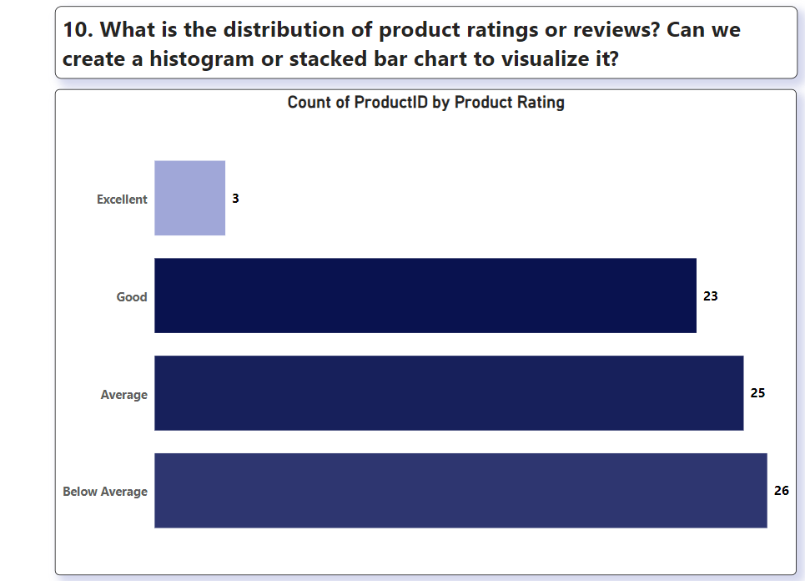

**Conclusions:**

* Most products are rated "Average" or "Below Average", with few "Excellent" ratings.

**Actionable Insights:**

* Focus on improving product quality and customer satisfaction.
* Conduct customer surveys to understand reasons for low ratings and implement improvement strategies.

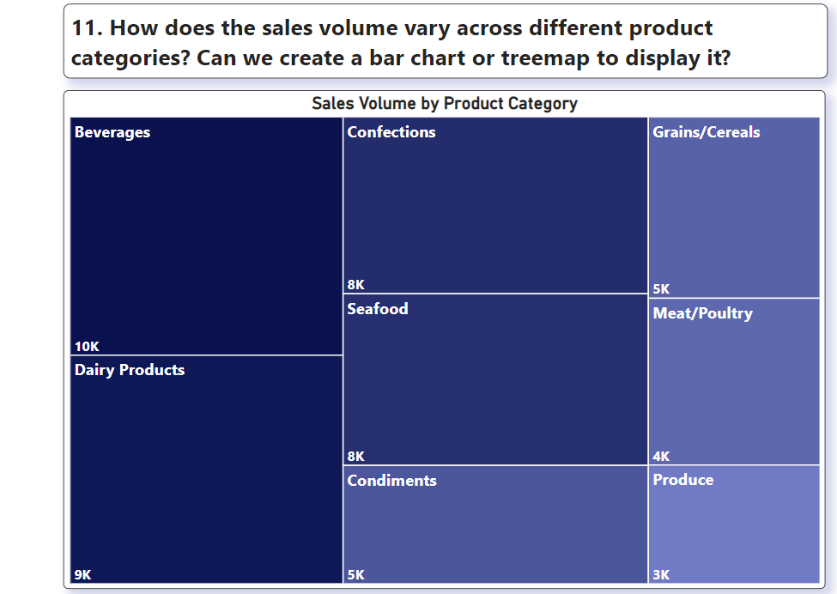

**Conclusions:**

* Beverages and Dairy Products are the top-selling categories.
* Produce and Meat/Poultry have lower sales volumes.

**Actionable Insights:**

* Capitalize on the success of Beverages and Dairy Products by expanding these product lines or running targeted marketing campaigns.
* Investigate reasons for lower sales in Produce and Meat/Poultry categories and develop strategies to boost their performance.

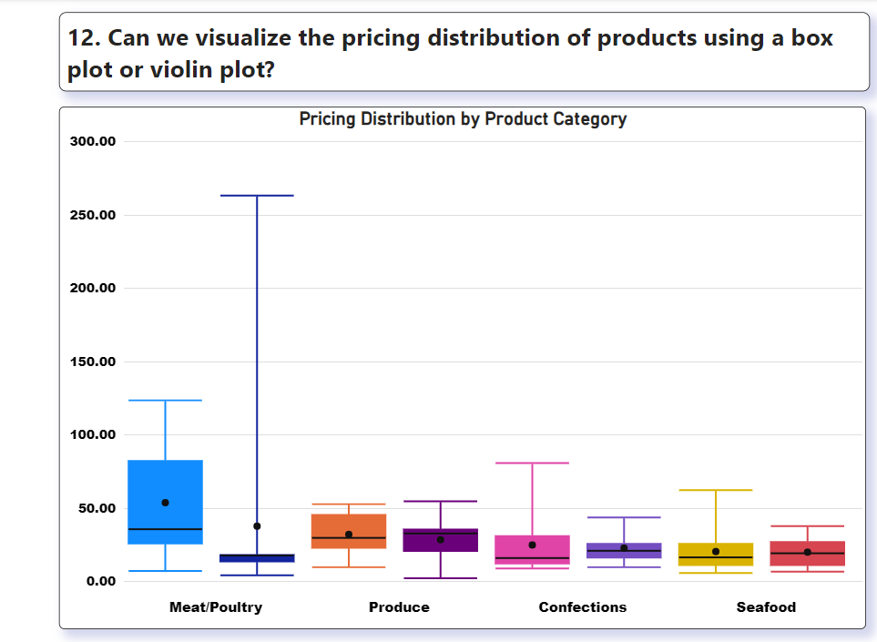

**Conclusions:**

* There's significant price variation across product categories, with Meat/Poultry having the widest range and highest median price.

**Actionable Insights:**

* Review pricing strategies, especially for categories with wide ranges. Consider optimizing prices for profitability while remaining competitive.

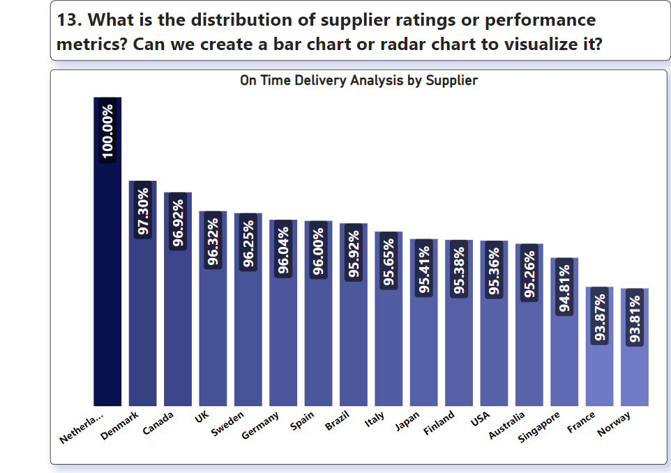

**Conclusions:**

* Netherlands leads in on-time delivery performance (100%), followed closely by Denmark and Canada.

**Actionable Insights:**

* Analyze practices of top-performing suppliers and apply learnings to improve overall supply chain efficiency.
* Consider renegotiating terms or finding alternatives for lower-performing suppliers.

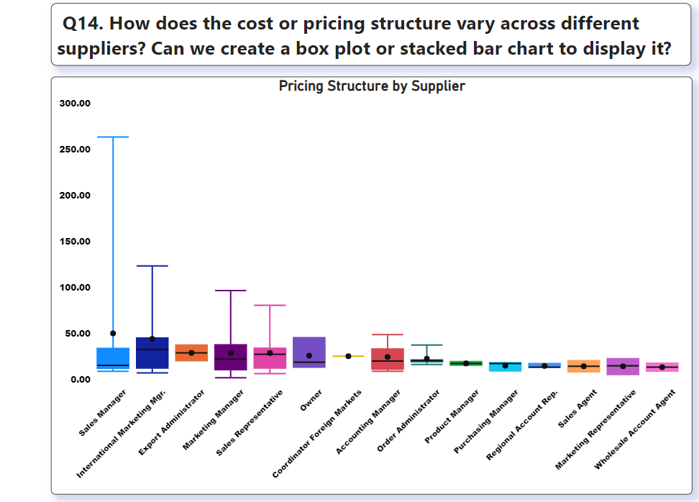

**Conclusions:**

* Sales Managers and International Marketing Managers have the highest and most variable pricing structures.

**Actionable Insights:**

* Review pricing authority and guidelines across roles. Implement consistent pricing policies while allowing flexibility where needed.

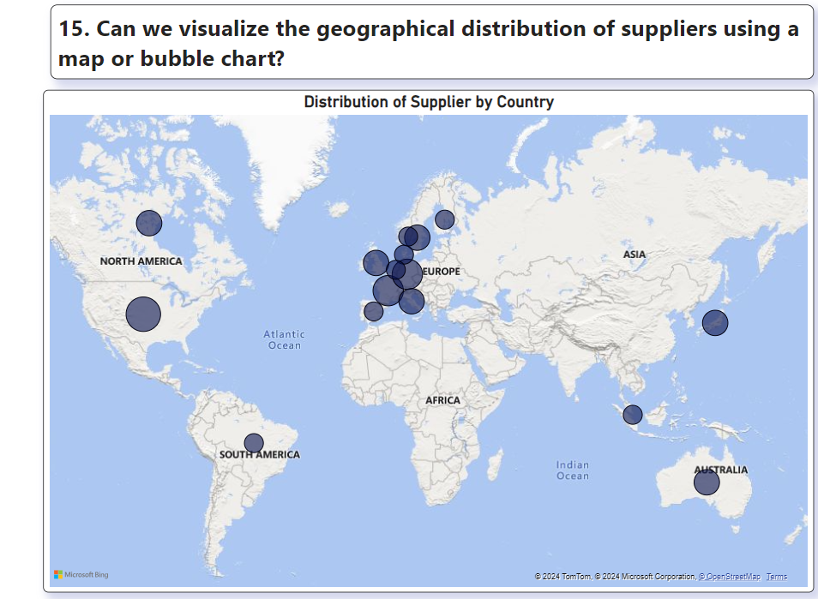

**Conclusions:**

* Suppliers are concentrated in Europe, with fewer in other regions.

**Actionable Insights:**

* Diversify supplier base geographically to reduce supply chain risks and potentially access new markets or products.

# DASHBOARD

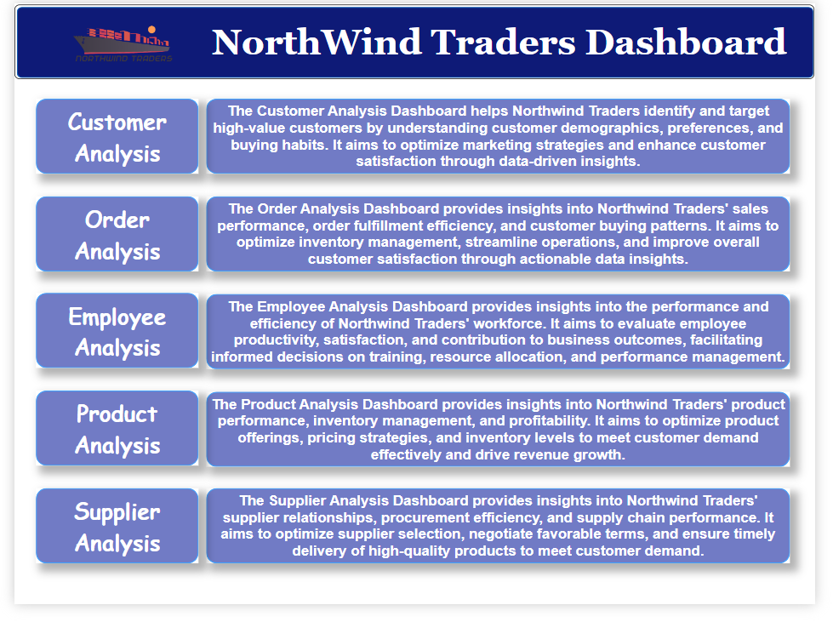

**CUSTOMER ANALYSIS DASHBOARD**

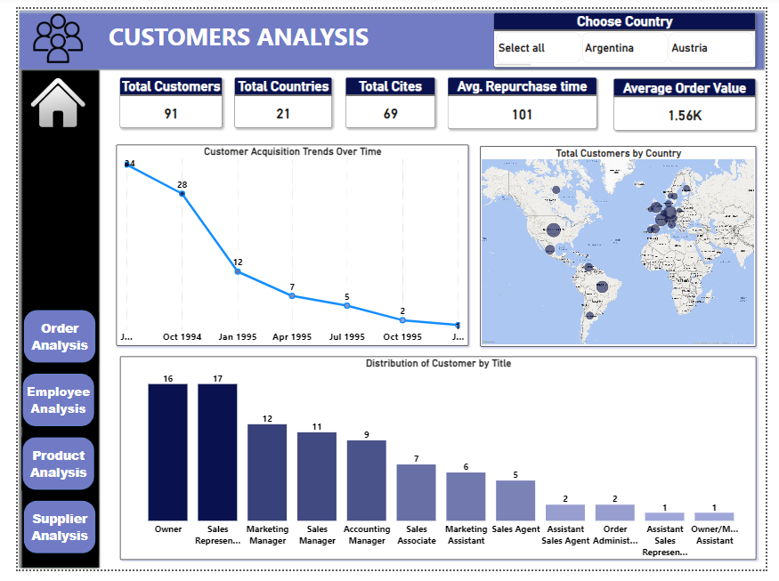

**ORDER ANALYSIS DASHBOARD**

# 

**EMPLOYEE ANALYSIS DASHBOARD**

# 

**PRODUCT ANALYSIS DASHBOARD**

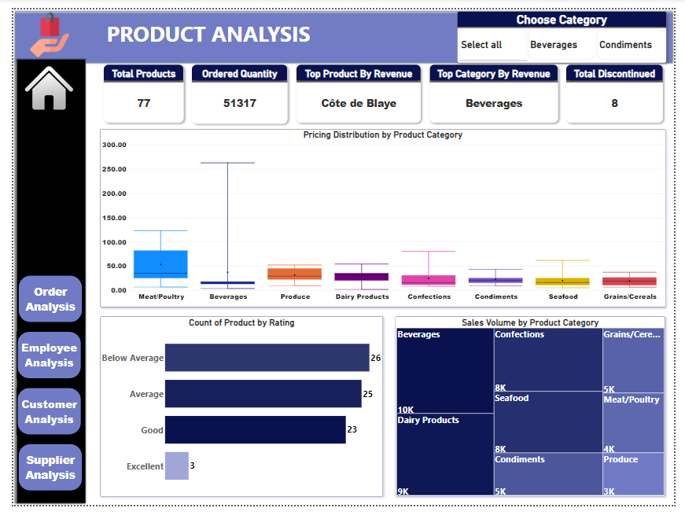

**SUPPLIER ANALYSIS DASHBOARD**

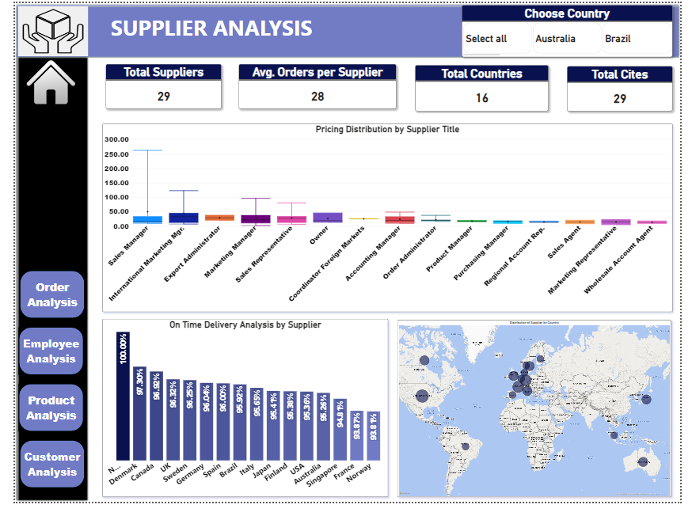

# EDA QUESTIONS

1. **What are the key factors influencing customer retention or loyalty based on the dataset?**
2. **How do customer preferences vary based on their location or demographics? Can we explore this through interactive visualizations?**
3. **Are there any interesting patterns or clusters in customer behavior that can be visualized to identify potential market segments?**
4. **Are there any specific product categories or SKUs that contribute significantly to order revenue? Can we identify them through visualizations?**
5. **Are there any correlations between order size and customer demographics or product categories? Can we explore this visually using scatter plots or heatmaps?**
6. **How does order frequency vary across different customer segments? Can we visualize this using bar charts or treemaps?**
7. **Are there any correlations between employee satisfaction levels and key performance indicators? Can we explore this visually through scatter plots or line charts?**
8. **How does employee turnover vary across different departments or job roles? Can we visualize this using bar charts or heatmaps?**
9. **Can we identify any patterns or clusters in employee skill sets or qualifications through visualizations? How can this information be used for talent management?**
10. **Are there any correlations between product attributes (e.g., size, color, features) and sales performance? Can we explore this visually using scatter plots or heatmaps?**
11. **How does product demand fluctuate over different seasons or months? Can we visualize this through line charts or area charts?**
12. **Can we identify any outliers or anomalies in product performance or sales using visualizations? How can this information be used for product optimization?**
13. **Are there any correlations between supplier attributes (e.g., location, size, industry) and performance metrics (e.g., on-time delivery, product quality)? Can we explore this visually through scatter plots or heatmaps?**
14. **How does supplier performance vary across different product categories or departments? Can we visualize this using stacked bar charts or grouped column charts?**
15. **Can we identify any trends or patterns in supplier costs or pricing structures through visualizations? How can this information be used for procurement optimization?**

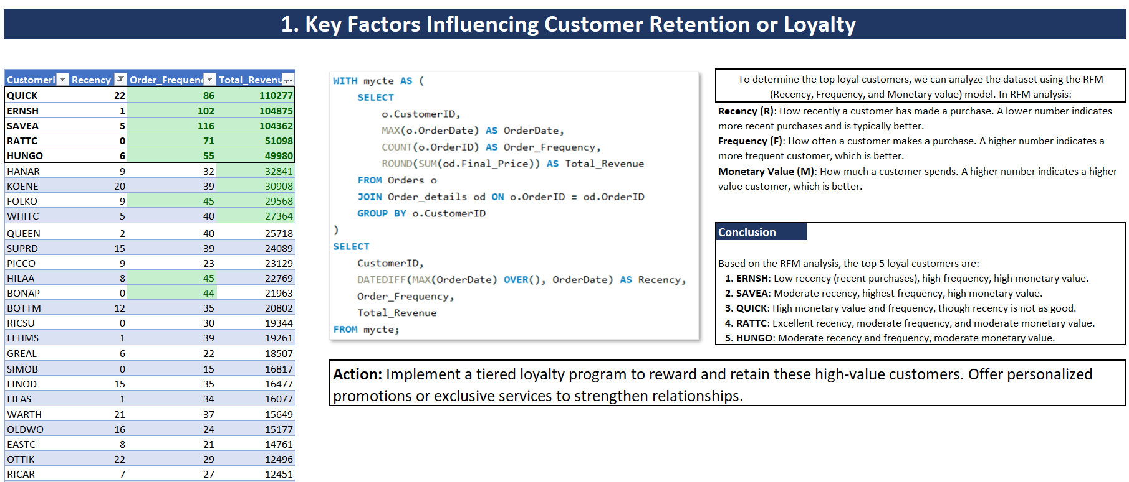

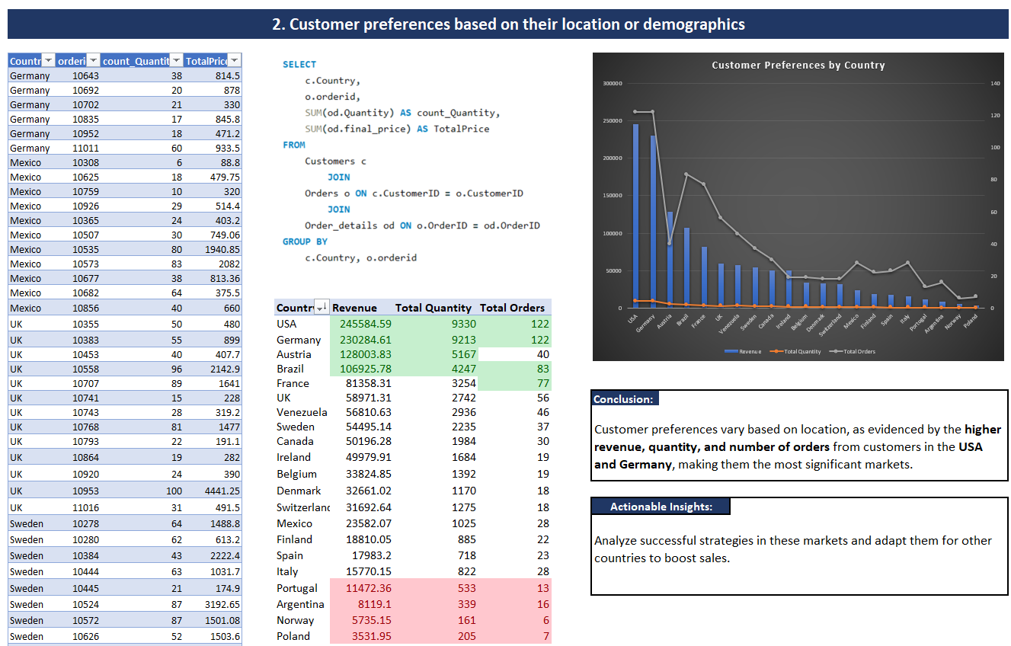

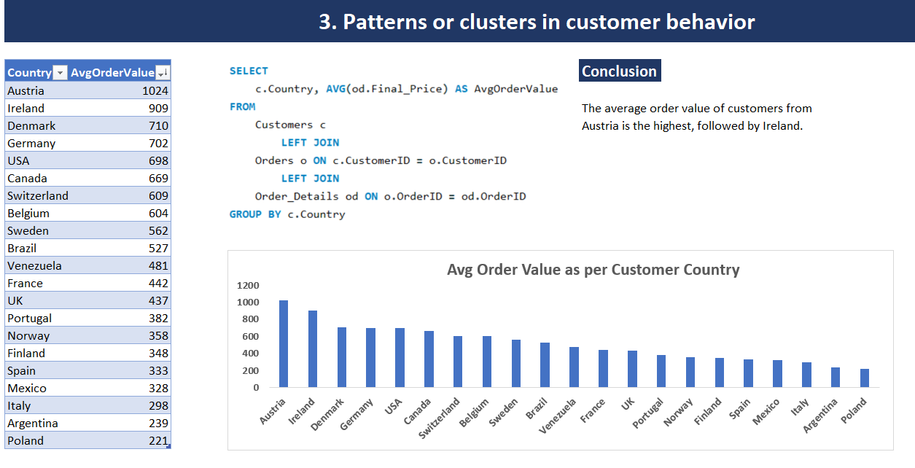

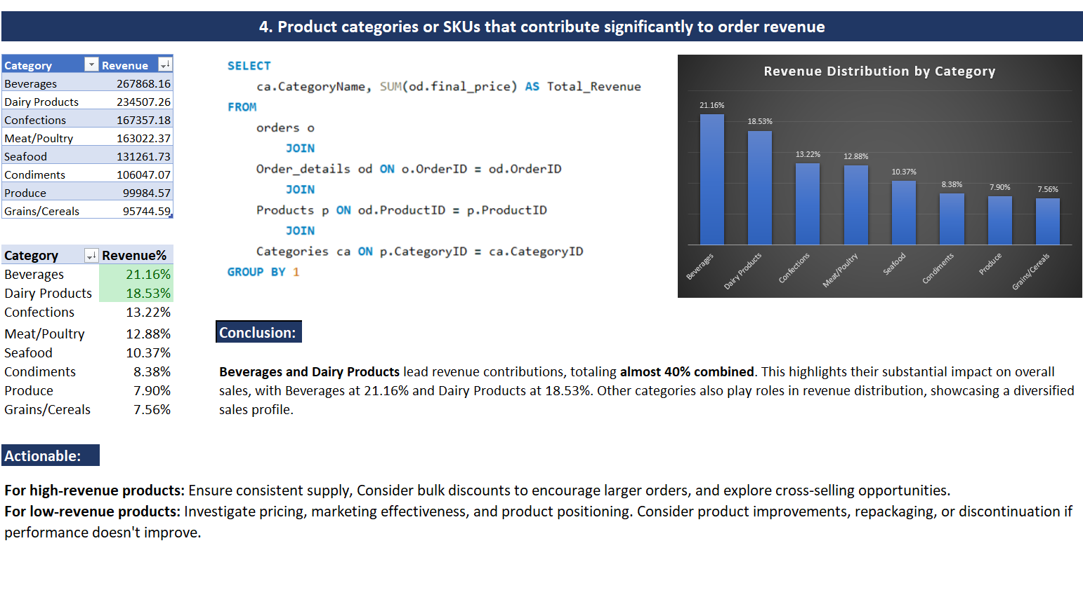

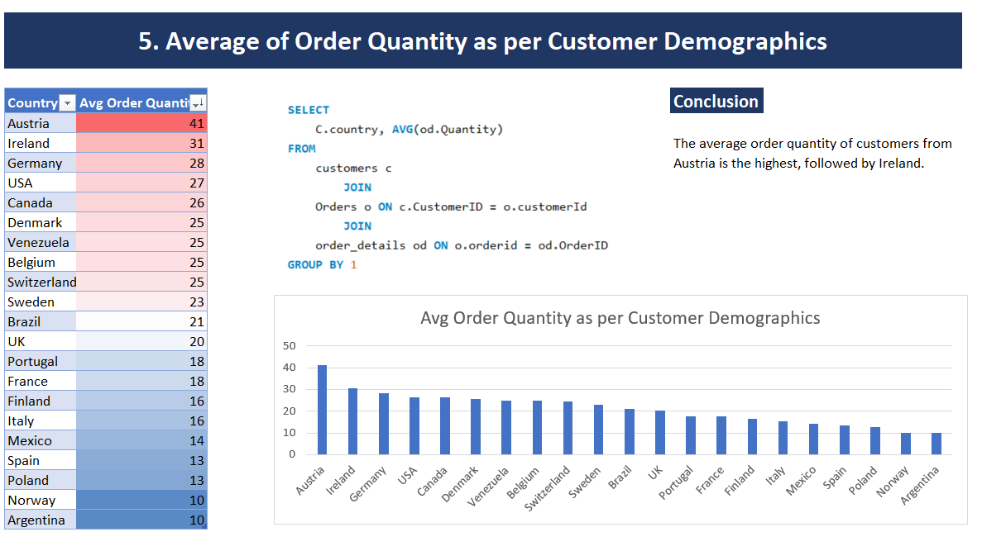

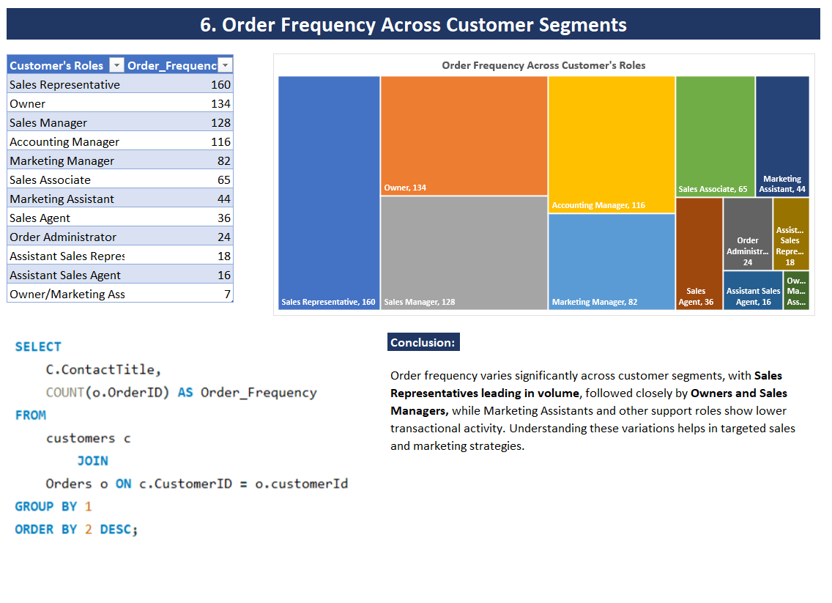

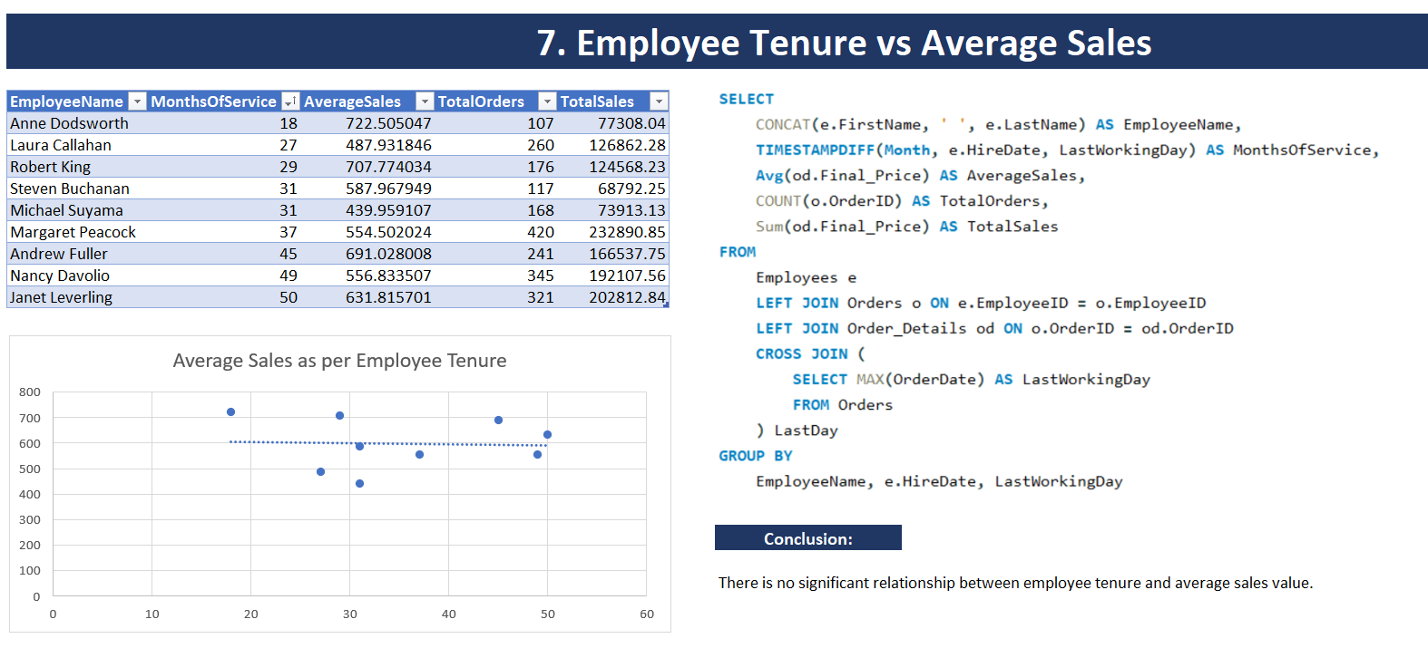

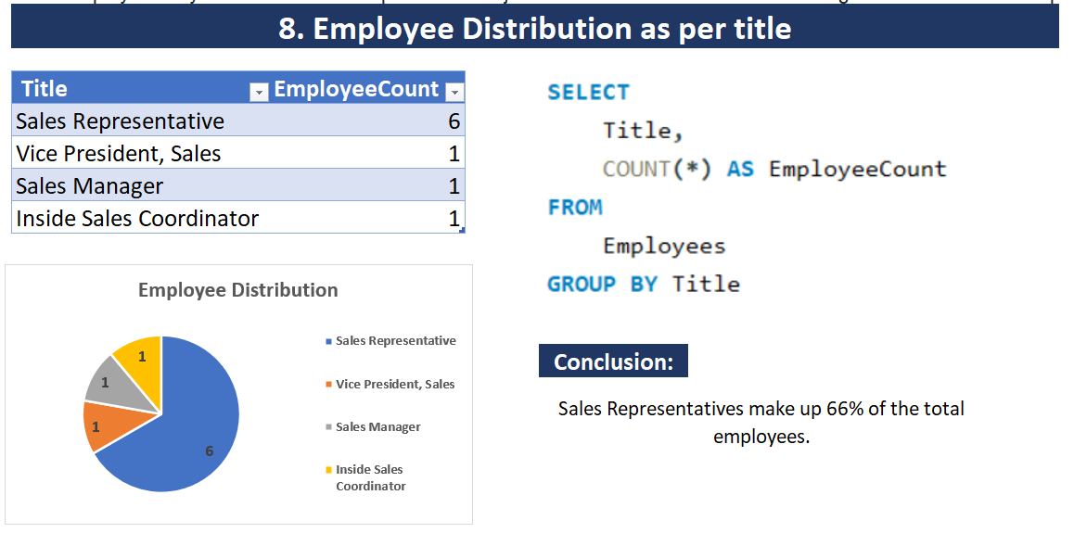

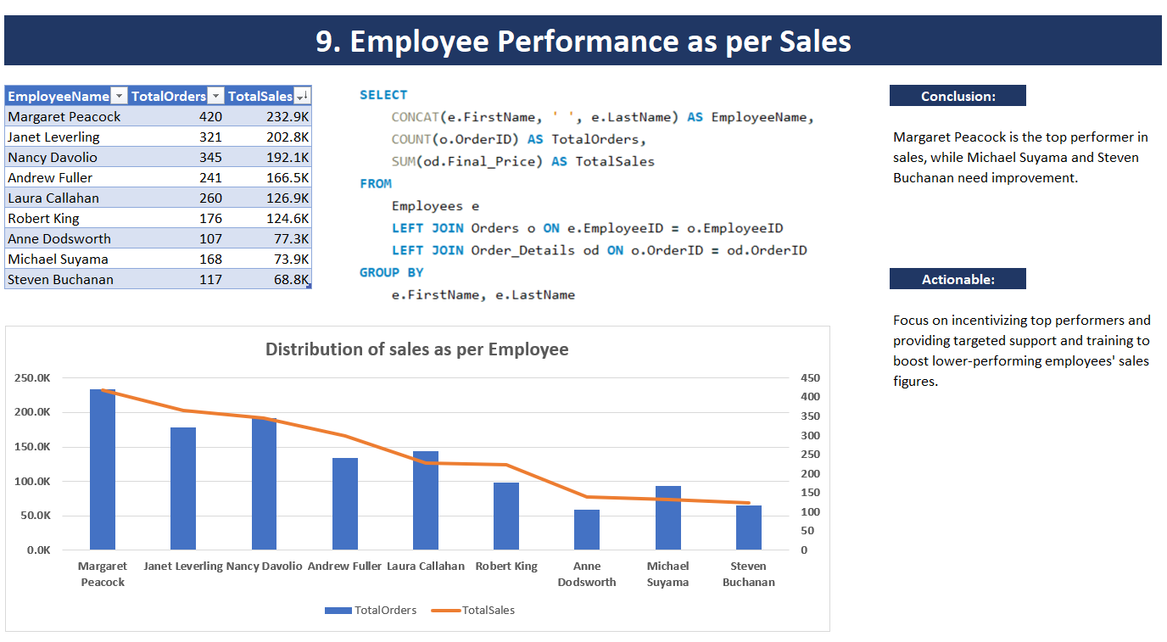

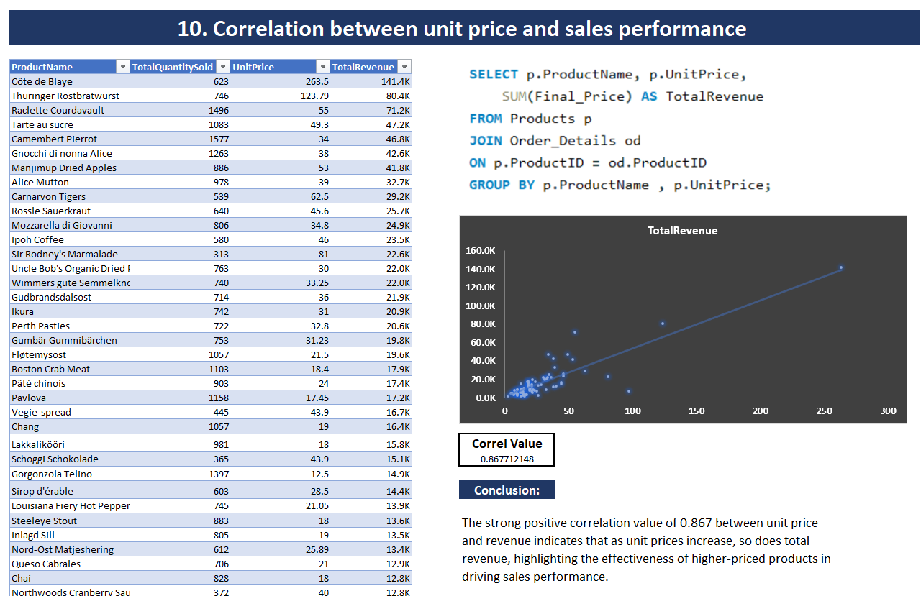

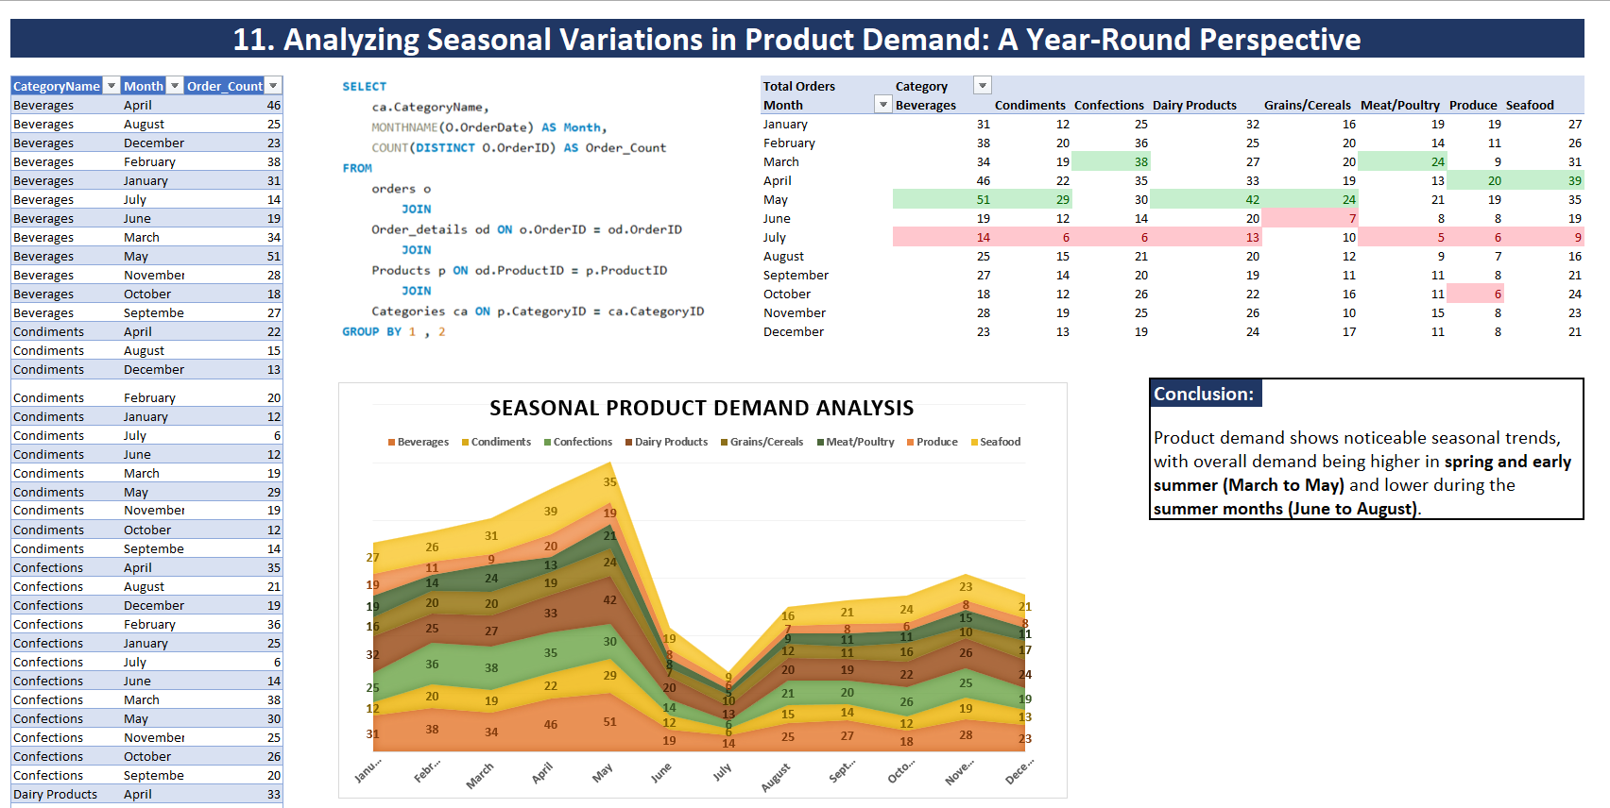

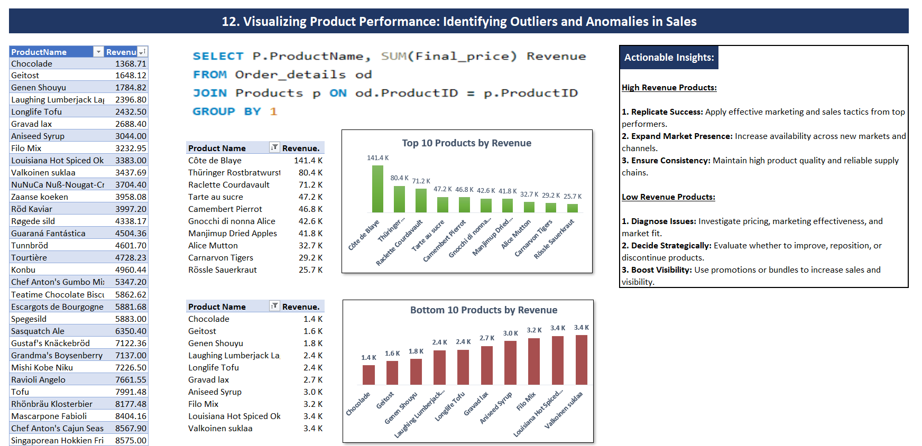

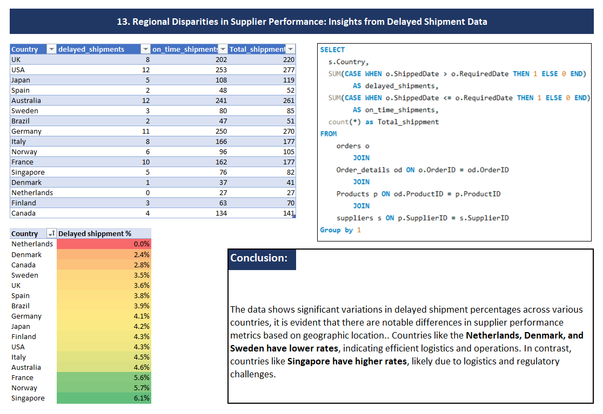

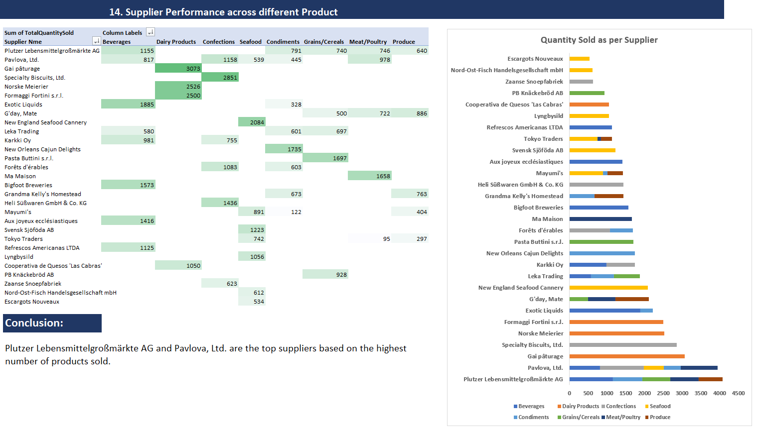

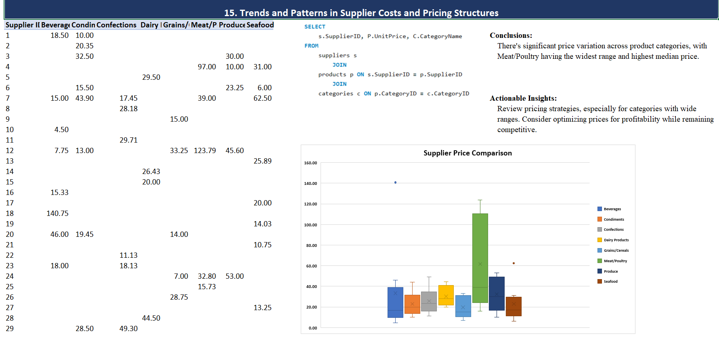

##### Conclusion:

By providing a visually compelling and user-friendly dashboard with interactive features, this Power BI report empowers stakeholders at Northwind Traders to make data-driven decisions. This comprehensive analysis of customers, sales, inventory, and employees offers valuable insights into business operations and facilitates data exploration. The expected impact is a transformation in how Northwind interacts with its data, ultimately enhancing competitiveness and driving the company forward in the wholesale market.